**Experiment 8**

**Aim/Overview of the practical:**

* How to create Storage account and upload the local data on Azure portal?

**Code/Steps for the Practical:**

**Step 1)** Go to Azure portal and login with your credentials.

**Step 2)** Click on **“Create a Resource”** in the top left corner.

**Step 3)** From the left menu click on **Storage**.

**Step 4)** After that from the right click on **create** **Storage Account card.**

**Step 5)** A create a storage Account window will appear fill in all the details such as Resource group, Storage Account name, Region, and Redundancy as LRS (Locally redundant storage) and after all that click on create.

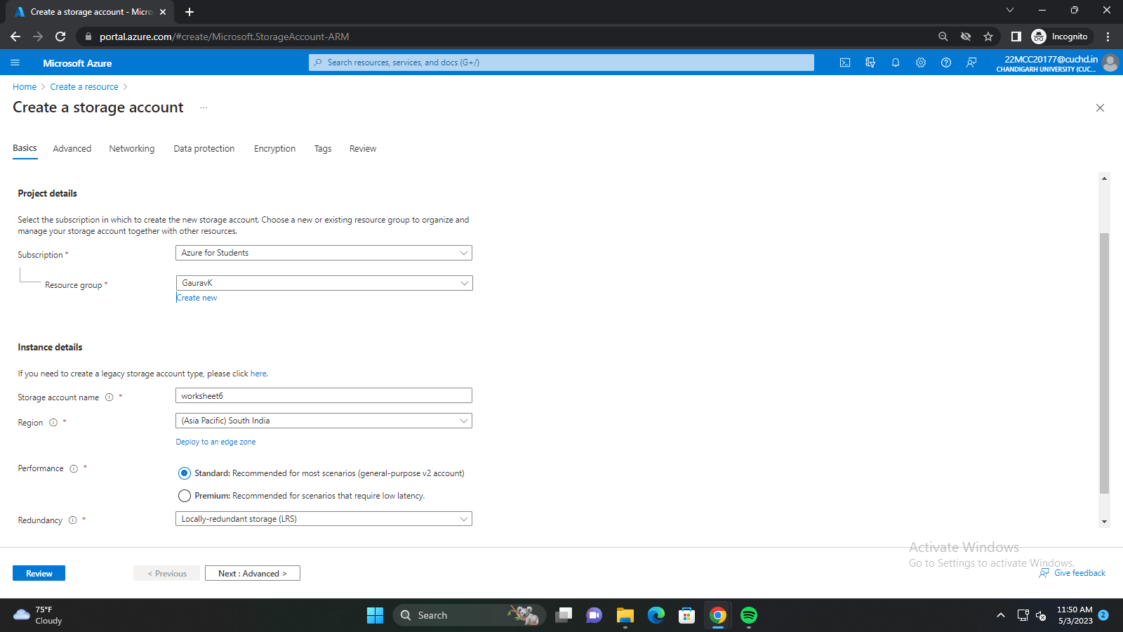

**Step 6)** After deployment is finished click on **Go to Resource.**

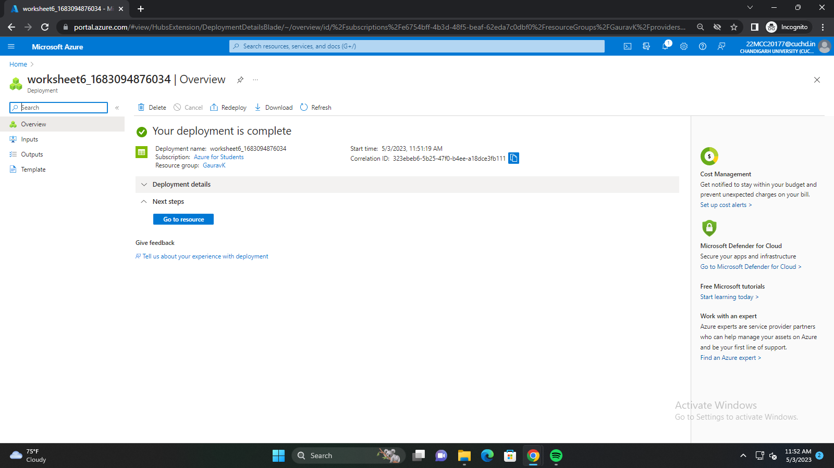

**Step 7)** From the left menu select **containers** under **Data Storage.**

**Step 8)** Then click on **+ Container** button on the top to create a new container.

**Step 9)** Give a name to your container and click on create.

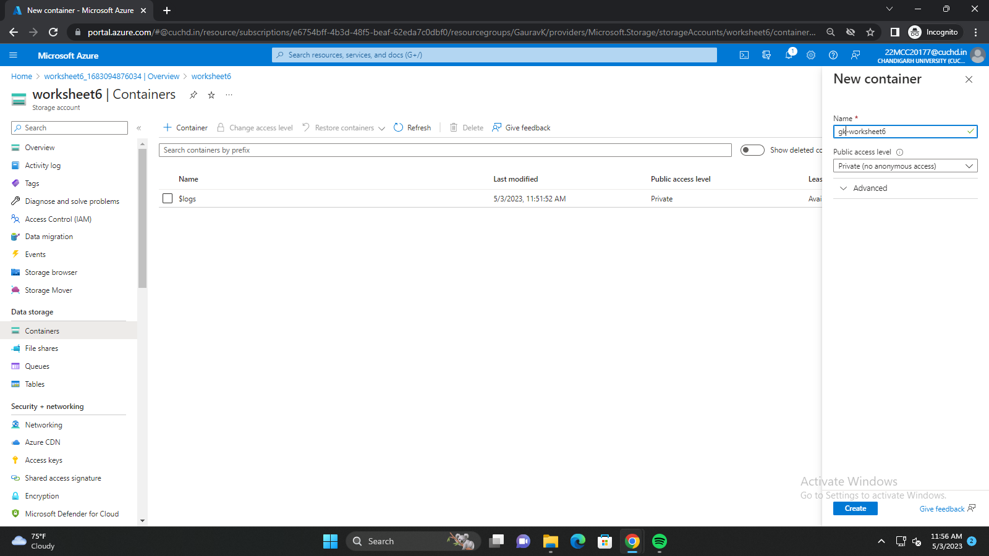

**Step 10)** Select newly created container and click on **Upload** button on top to upload local files to azure cloud.

**Step 11)** A will appear on the left side of screen **Drag and Drop or Browse files** which you want to upload into it and click on **the Upload** button.

**Step 12)** Files will be uploaded onto the Azure Portal and you can access those files from anywhere over the internet.

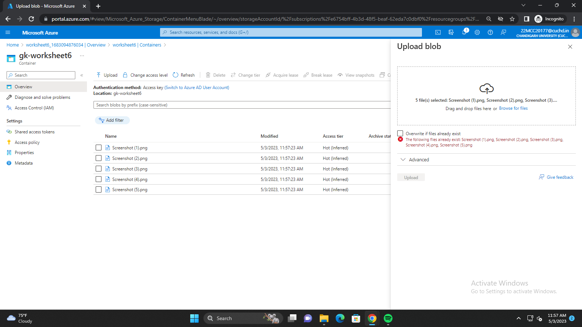

**Learning Outcomes (What I have learned)**

* I Learned to: -
  + - * Create Storage resources in the azure portal.
      * Create Copy of your local data on azure portal.

**Evaluation Grid:**

|  |  |  |  |
| --- | --- | --- | --- |
| Sr. No. | Parameters | Marks Obtained | Maximum Marks |
| 1. | Demonstration and Performance  (Quiz) |  | 22 |
| 2. | Worksheet |  | 8 |